**PL-SQL PROGRAMS FOR CONTROL STRUCTURES**

**Q.Write a PL/SQL code block that will accept an account number from the user ,check if the users balance is less than minimum balance (5000) ,only then deduct Rs. 100/- from the database The process is fired on the ACCT_MSTR Table.**

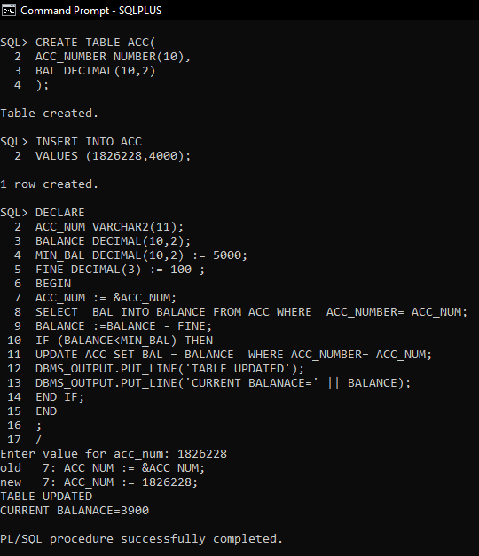

**Q.Write a PL/SQL code block to calculate the area of circle for a value of radius varying from 3 to 7. Store the radius and corresponding values of calculated area in empty table names Areas ,consisting of two columns Radius and Area.**

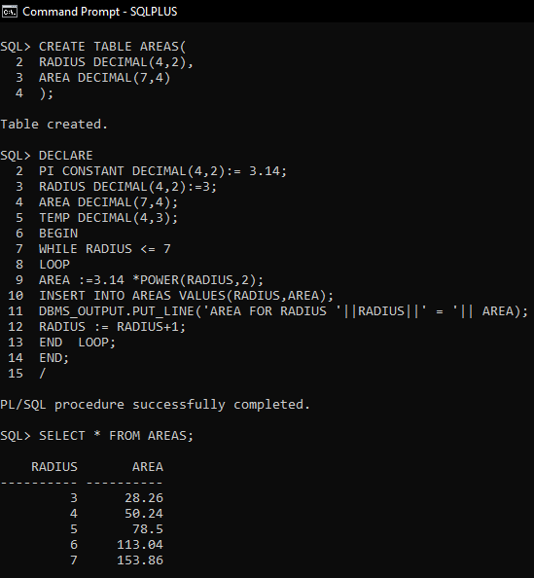

**Q.PL/SQL Program To Add Two Numbers**

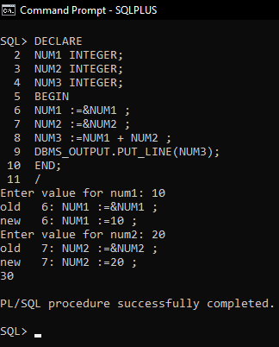

1. **PL/SQL Program for Prime Number**

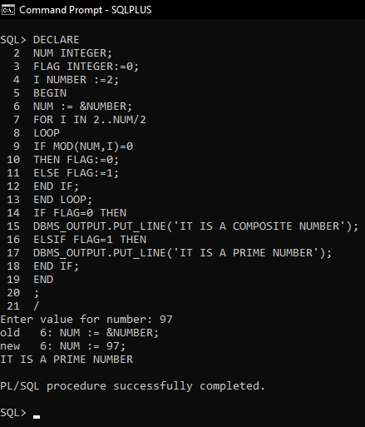

**Q.PL/SQL Program to Print Table of a Number**

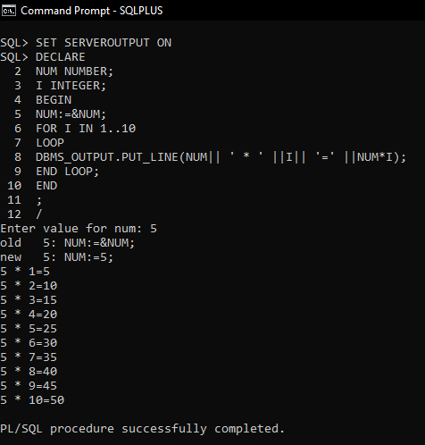

**Q. PL/SQL Program for Reverse of a Number**

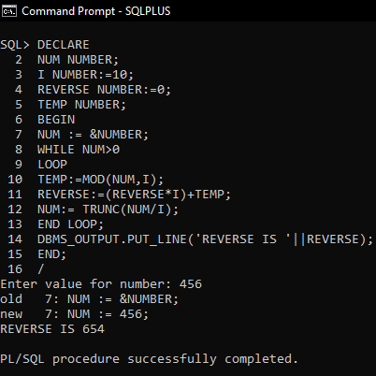

**Q.** **PL/SQL Program for Fibonacci Series**

